Luminary Micro DesignStellaris2006 Entry
Registration Number LM1770
Stellaris microcontroller: LM3S811

Copyright 2007 by Chuck Baird
http://www.cbaird.net
All rights reserved

Recycling Binary Trees
Abstract

Text Description

This entry describes and demonstrates an algorithm for the efficient recovery and reuse of memory resources allocated to data structures known as binary trees. Entire subtrees may be reclaimed by the garbage collection system without subtree traversal, and individual nodes are subsequently picked out of the pool of available nodes (and removed from recycled subtrees as appropriate) for reallocation.

Reclaiming subtrees of any size is accomplished through updating 2 pointers. Allocation of nodes, regardless of their original position in a reclaimed subtree, is accomplished through a worst case updating of 3 pointers, all available within one level of indirection.

A program was written to give a graphical display of an application of the algorithm. It was implemented on a Stellaris LM3S811 Evaluation Kit board with its OLED 96x16 pixel display. A 5 level, 63 node binary tree is continually built and modified by using random selection of leaves for adding and nodes for subtree deletion. The same 63 nodes are allocated and recycled, demonstrating the power of the algorithm.

Photograph of Project

This being a software project demonstrating a binary tree node allocation/recovery algorithm, there was no modification or hardware additions to the LM3S811 Evaluation Kit board.

In the photograph the display shows a 47 node binary tree, with the root at the top center, and several 5th level leaves along the bottom edge. There are 16 nodes available (in the garbage pool) available for allocation. The 5 level tree can have a total of 63 nodes.

The potentiometer controls the speed of updates, ranging from about 1/60th of a second to 3 seconds per pause. A bottom level leaf is randomly added (if it doesn’t exist), then a pause, then a random node and its descendents is removed (if it exists), then a pause. Pressing the user button inhibits the destruction half of the cycle, so the tree rapidly builds to completion.

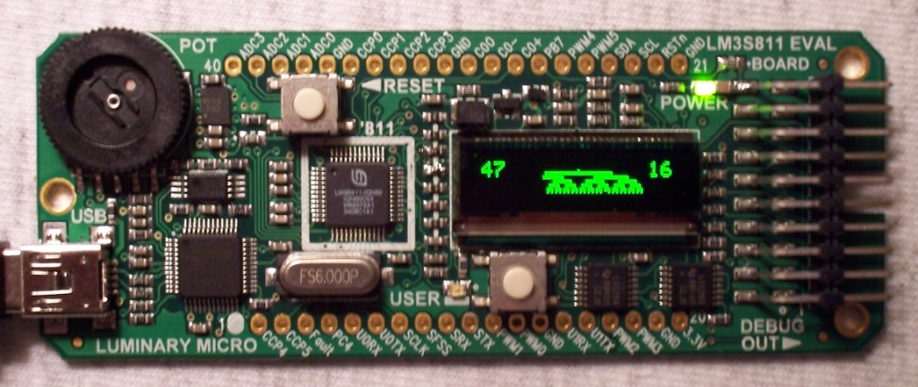

Block Diagram

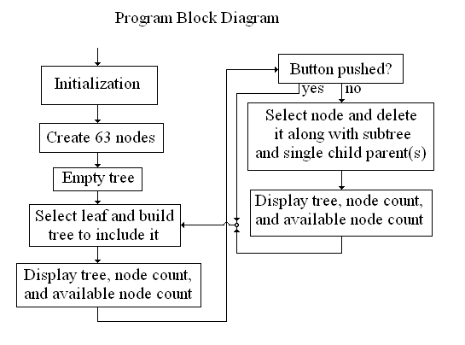

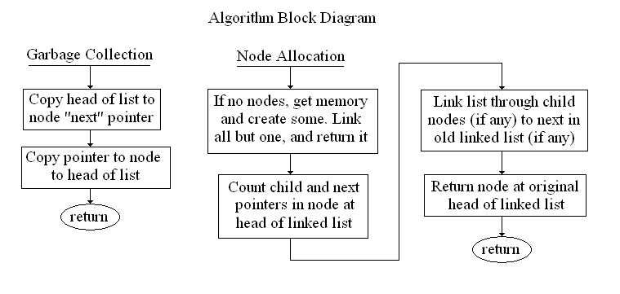

Schematic

There was no additional hardware other than that supplied on the LM3S811 Evaluation Kit board.

Sample Code

// ====================================================================
// the famous algorithm: toss_me() and gimme()
//
// these two routines implement the algorithm to allocate nodes
// and reclaim nodes and/or subtrees.
//
// (more comments omitted for abstract)
//
// -------------------------------------------
// toss_me - put a node into the garbage pool
//
// this links a node (with or without children) into the
// linked list of available nodes. the newly added node
// goes at the front of the list.
//
// the variable garb is the head of the linked list.
//
void toss_me(struct bt_node *p) {
(*p).u.nxt = garb; // we point to old head
garb = p; // head points to us
}

// -------------------------------------------
// gimme - get a node from the garbage pool
//
// this routine returns a pointer to the first node in
// the garbage list, and relinks its children (if any)
// and the remaining nodes. the returned nodes has
// undefined data in all fields.
//
// (more comments omitted for abstract)
//
struct bt_node *gimme(void) {
struct bt_node *rtn, *p, *ww[3];
int i, n, who[3];

rtn = garb; // the node we'll return
if (rtn) {
n = 0; // count the # of non-null pointers
for (i = 0; i < 2; i++) { // child pointers
p = (*rtn).ptr[i];
if (p) {
ww[n] = p;
who[n++] = i;
}
}
if ((*rtn).u.nxt) { // linked list pointer
ww[n] = (*rtn).u.nxt;
who[n++] = 2;
}

// the relinking strategy depends upon how many non-null
// pointers there were in the node we're returning

switch (n) {
case 1:
garb = ww[0]; // head --> our target
if (who[0] < 2)
(*garb).u.nxt = NULL; // if child, no next pointer
break;

case 2:
garb = ww[0]; // head --> first target
p = ww[1]; // 2nd target
(*garb).u.nxt = p; // 1st --> 2nd
if (who[1] == 1) // if 2nd is a child, define
(*p).u.nxt = NULL; // its nxt pointer
break;

case 3:
garb = ww[0]; // head --> first child
p = ww[1]; // second child
(*garb).u.nxt = p; // ch1.next --> second child
(*p).u.nxt = ww[2]; // ch2.next --> orig next
break;

default:
garb = NULL; // last node in the pantry
break;
}

// the following code handles the allocation of new memory

} else { // no available nodes
// ====== code omitted for abstract =====
}
(*rtn).ptr[0] = NULL; // be discrete (not required)
(*rtn).ptr[1] = NULL; // and help prevent accidents
(*rtn).u.nxt = NULL;
return (rtn);
}

